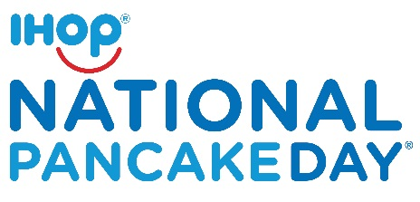
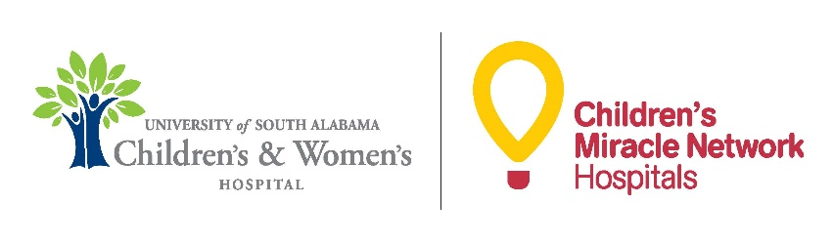

FREE Short Stack of Pancakes on IHOP National Pancake Day®

When: Tuesday, February 27; 7 a.m. – 7 p.m.

Where: At participating IHOP restaurants in Mobile and Baldwin Counties.

Why: Help local children in our community being treated for life-threatening illnesses and injuries.

Details: Guests can receive one FREE short stack of buttermilk pancakes* while making a voluntary donation to USA Children’s & Women’s Hospital through Children’s Miracle Network Hospitals.

Children’s Miracle Network Hospitals raise funds for 170 member hospitals across North America, which, in turn, uses the money where it is needed the most.

Celebrate IHOP National Pancake Day and help raise $5 million for your local Children’s Miracle Network Hospitals!

Find an IHOP near you: www.IHOP.com

*Guests can receive one free short stack of buttermilk pancakes at participating IHOP Restaurants nationwide on Tuesday, February 27 2018 (IHOP National Pancake Day) from 7a.m.-7p.m.; some locations hours may vary. Please check with your local IHOP for exact hours of participation. Limit one offer per guest. Dine-in only.

