In order to prevent the spread of COVID-19 from people who may have the virus but no symptoms to others, the City of Los Angeles is requiring its citizens to wear masks when out in public. Due to a lack of PPE resourcing around the world, we are calling for volunteers to help make masks to support CHLA staff and visitors to the hospital. Since these handmade masks are not medical grade they will be used by the many non-clinical staff and guests that require protection.

Materials & Quantities
- 3 yards, 9 inches of white, 100% cotton fabric
- 15 yards of ¼” elastic

These quantities and guidelines will produce 10 “large” masks and 30 “small” masks for a total of 40 masks.

Return directions:
- Masks must be laundered after being sewn in cold water and dried on a low setting to prevent from shrinking.
- Finished and washed masks must be packed in a zip lock bag
  - Please handle your laundered masks with gloves order for them to remain sterile.
  - Separate masks by size into labeled zip lock bags— Large or Small
- Label your bag in large clear lettering with:
  - Your name or name of the person who made them
  - Number of masks inside (if necessary, use multiple bags - label bag 1 of 1 etc.)

- Mail or drop off completed masks
Mail to:
CHLA
4650 Sunset Blvd., #64.
Los Angeles, CA 90027
Attn: Rosby Lamm

Drop Off:
CHLA Loading Dock
4616 DeLongpre Ave.
Los Angeles, CA 90027
Attn: Rosby Lamm

Mask Requirements:
- 100% cotton fabric
- Must be made from 3 layers of fabric
  - TIP: If you hold your 3 layers up to a light and still see light coming through them, you’ll need to add another layer.
- The “inside” of your masks must be labelled with a permanent marker on one of the side of the masks
  - This ensures the “wearer” can put it on again with the same side facing in.

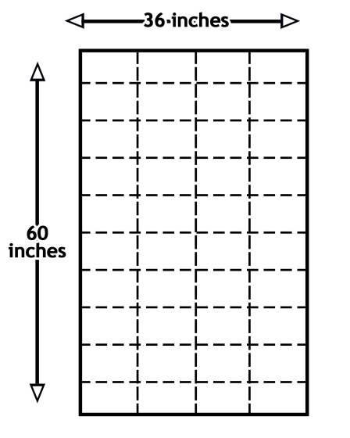
Cutting your fabric:
Every yard (36” by 60”) of fabric can produce 13 masks with one extra piece.
- We suggest cutting your 9” by 6” rectangles out three layers at a time. This saves you some time if your scissors can handle the thicker cut.
- If you have 3 yards or more of fabric, we suggest cutting them into 1 yard pieces first. Then, lay them on top of each other to cut out your 9” by 6” rectangles.
  - 3 yards of fabric (36” by 60”) will produce 40 masks exactly with no extra material.

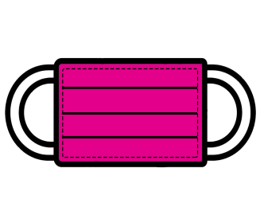
Elastic-band sizing, Large and Small:
- 8” for LARGE – 2 pieces (16” cut in half for each mask)
  - Please make 3 of this size for every yard, 10 if making 40 masks
- 6” for SMALL – 2 pieces (12” cut in half for each mask)
  - Please make 10 of this size for every yard, 30 if making 40 masks

On behalf of our team members, patients and families
THANK YOU for your service to CHLA.

